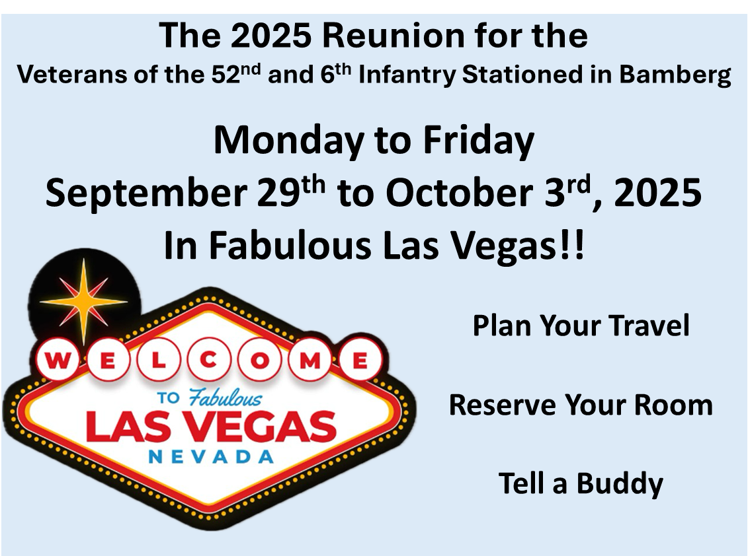

**2025 Reunion** –

The Veterans of the 52nd and 6th Infantry Regiments Stationed in Bamberg are pleased to announce our 2025 reunion.

We will gather in Las Vegas Monday to Friday, September 29th to October 3rd, 2025.

Our reunion hotel is the Tuscany Suites and Casino, 255 E. Flamingo Road. They are offering $79 a night room rate (plus tax) for the four nights without additional resort, parking, or internet fees.

In this document, we provide the information that we have now – a year in advance of the reunion. We will continue to update this information as our plan develops.

You should do the following things now:

* Plan your trip to Las Vegas
* Reserve your room
* Call a buddy and ask him to join you in Las Vagas.

**Travel to Las Vegas**

Air Travel –

* Las Vegas has outstanding regular air service from many US cities to Harry Reid International Airport (LAS).
* We selected our reunion dates (Monday to Friday, vs our traditional Wednesday to Friday dates) because airline rates are cheaper during the week than on weekends to Las Vegas – by 20-30% - opposite of what it is in most places.
* You probably don’t need to rent a car in Las Vegas – the airport is a short taxi ride from the hotel, and the central location of our hotel means you can walk, take short taxi / Uber rides, or public transportation to get around.

Car Travel –

* If you drive, the reunion hotel offers free parking.

**Reunion Hotel**

Hotel Information

* We will gather in Las Vegas Monday to Friday, September 29th to October 3rd, 2025.
* Our reunion hotel is the Tuscany Suites and Casino, 255 E. Flamingo Road.
* They are offering a $79 a night room rate (plus tax) for the four nights without additional resort, internet, or parking fees.
* The Clark County room tax is currently 13.38% - subject to change.
* The hotel also offers favorable rates for the days before and after these dates if you want to extend your stay (these are called shoulder rates.) The rates are
  + Sunday, September 28th - $79 a night
  + Friday, October 3rd - $195 a night
  + Saturday, October 4th - $195 a night

Hotel Features

* We conducted our first reunion in 2010 in Las Vegas and we are pleased to return to the Tuscany Suites hotel, which we recently visited for a reunion recon.
* Our hotel rooms will be a 650 square-foot room, with sofa, and eating area.
* Great location, two blocks from ground zero of the strip - Bellagio, Caesars Palace, Flamingo, and Horseshoe Casino, the High Roller observation wheel, and the Sphere.
* In hotel casino, pool, and great places to eat.
* And we will have a traditional hospitality suite where you can gather with your friends.

Hotel Sign Ups – You can sign up for your hotel room now.

* Online - <https://res.windsurfercrs.com/ibe/details.aspx?propertyid=16539&nights=1&checkin=9/28/2025&group=2025REUNION&lang=en-us>
* Phone – call 702-893-8933 with the code: **2025REUNION**

**Tentative Reunion Schedule**

This is all still tentative, but here is a first good shot of our reunion schedule.

Costs of events are also estimates for now.

**Monday**

                12 Noon – 10 PM – Hospitality Suite Open – Check in – Rotating Exhibits

                12 Noon - 5 PM – Individual Touring – Recommended  - Big Bus Tour

                5 PM – Happy Hour – Hospitality Suite

                6 PM – Dinner on Your Own – Recommendation – Yard House

**Tuesday**

8 AM - 10 PM – Hospitality Suite Open – Check in – Rotating Exhibits

8 AM – Breakfast Marilyns Café in Hotel or Donuts in Hospitality Suite

10 AM - 3 PM – Walking Tour – Las Vegas Strip / Lunch on Your Own

4 - 5 PM – Annual Meeting – Hotel

5 - 7 PM – President Reception – Hotel Ballroom – Cost $35 pp

7 PM – Dinner on Your Own – Recommendation Pub 365 in Hotel

**Wednesday**

9 AM -12 Noon – Hotel Ballroom

Continental Breakfast - $25 pp

Memorial Service

Battalion Exhibits and Videos

1 - 4 PM – Lunch – Hofbräuhaus - $50 pp

4 - 10 PM – Hospitality Suite Open – Check in – Rotating Exhibits

5 PM – Happy Hour – Hospitality Suite

6 PM – Dinner on Your Own – Recommendation – Firefly Tapas Kitchen and Bar

**Thursday**

8 AM - 6 PM – Hospitality Suite Open – Check in – Rotating Exhibits

8 AM – Breakfast Marilyns Café in Hotel or Donuts in Hospitality Suite

10 AM – Group Photo – Fountain at Bellagio Casino

10 AM - 3 PM – Walking Tour – Old Las Vegas / Lunch on Your Own

6 PM – Reception – Hotel Ballroom

7 PM – Banquet – Hotel Ballroom $65 pp

**Friday**

8 AM - 12 Noon – Hospitality Suite Open – Farewells

8 AM – Breakfast Marilyns Café in Hotel or Donuts in Hospitality Suite

**Other Reunion Features**

* The reunion committee is already working hard to make this a memorable gathering, collecting memorabilia, pictures, and videos they will display at the reunion.
* Over the next year, using the reunion as motivation, our reunion committee wants to capture a more detailed history of the battalion during our time in Bamberg, focused on what it meant to be a soldier in 1-52 / 7-6 Infantry during the cold war.
* And then you want to be able to display that history at the reunion in a manner that brings that experience alive for both those who attend the reunion and for those who cannot.
* This is a yearlong project, and the reunion committee wants to involve many of you in gathering this history.

**Reunion Costs**

* We are working to keep the costs of the reunion reasonable for maximum participation.
* Las Vegas is more expensive on the weekends, both for hotels and flights in and out.  That is what we have chosen a Monday to Friday reunion vs our traditional Wednesday to Friday.
* We have a $79 a night room rate (plus tax), which is $20 cheaper than our previous cheapest room rate.
* Roundtrip airfare from many cities is currently $200-300 for during the week travel to Las Vegas.
* We are working to keep cost of dinners and receptions reasonable and offset costs of drinks and the Hofbrauhaus through our fundraising efforts.

**More to Follow**

* Save the dates.
* Sign up for your hotel room and make your travel plans now.
* Event sign ups will come after the first of the year.
* More information to follow – including a complete reunion guide.
* If questions, contact Mike Streff, Bill Burt, or Robert Pruitt.